VR Study Demonstrates Significant Anxiety Reduction in Cancer Patients Before Radiation Therapy

Feasibility trial with Penn Medicine shows Novobeing’s immersive mindfulness programs are promising supportive tools for oncology care
BOSTON, October 3, 2025 — Novobeing, a therapeutic virtual reality (VR) company delivering clinically validated experiences proven to reduce stress, anxiety, and pain, today announced the publication of new research demonstrating significant reductions in anxiety among cancer patients preparing for radiotherapy.
Conducted in collaboration with Penn Medicine’s Abramson Cancer Center and the Department of Radiation Oncology in the Perelman School of Medicine at the University of Pennsylvania (Penn), the IRB-approved pilot study demonstrated both feasibility and clinical impact for the VR-based intervention.
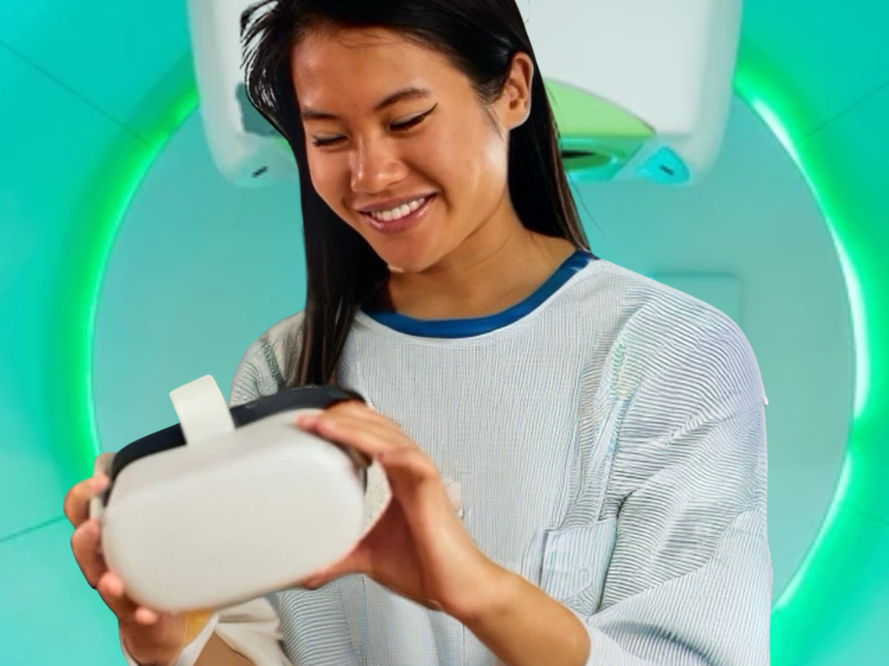

A patient uses Novobeing’s Therapeutic VR platform before undergoing radiotherapy. A new study with Penn Medicine found the experience significantly reduced anxiety levels in cancer patients.

The clinical study, conducted from April 2024 to February 2025 at the Hospital of the University of Pennsylvania, enrolled 25 patients with thoracic cancers. The intervention consisted of an 8-minute Novobeing mindfulness session delivered immediately before the CT simulation.
Despite most participants having no prior VR experience and the median age of 65+, 100% of patients completed the program, meeting the study’s primary endpoint of feasibility.
Patients experienced measurable changes across all six domains of the State-Trait Anxiety Inventory (STAI-6) after a single 8-minute VR session:

Negative Emotion Reductions
- “I am worried”: 2.2 → 1.4 (36% decrease, p = 0.0004)
- “I am tense”: 2.1 → 1.4 (33% decrease, p = 0.004)
- “I feel upset”: 1.7 → 1.2 (29% decrease, p = 0.001)

Positive Emotion Improvements
- “I am relaxed”: 2.6 → 3.4 (31% increase, p = 0.003)
- “I feel content”: 2.6 → 3.3 (27% increase, p = 0.007)
- “I feel calm”: 2.8 → 3.5 (25% increase, p = 0.002)
These changes reflect both statistical and clinical significance, supporting the feasibility and emotional impact of VR-guided mindfulness in a high-stress clinical setting.
Pre-intervention assessments showed borderline to clinically abnormal levels of anxiety and depression at baseline. Following the VR session, patients consistently reported a sense of greater calm, with 92% indicating they would use the intervention again and 88% saying they would recommend it to other patients.
“Cancer care doesn’t begin with treatment; it begins with mindset,” said Principal Investigator Michael LaRiviere, MD, an assistant professor of Radiation Oncology at Penn. “This study shows that even a brief, guided mindfulness experience in VR can reduce anxiety and help patients feel more emotionally prepared for treatment. That’s an extraordinary return for such a short non-pharmacological intervention.”
Participants included adults aged 34 to 84, with a median ECOG performance status of 1. Despite 68% reporting no previous experience with VR, the intervention was well tolerated, and no adverse effects were reported.
“This collaboration with Penn Medicine strengthens our commitment to delivering evidence-based VR interventions that are both effective and accessible,” said Sid Desai, Co-Founder and CEO of Novobeing. “This study demonstrates that even short, intuitive VR sessions can provide measurable relief during high-stress medical procedures.”
The abstract, “Virtual Reality (VR)-Based Mindfulness Practice and Anxiety in Patients Preparing for Radiotherapy”, was presented at the 2025 American Society for Radiation Oncology (ASTRO) Annual Meeting and is now available in the International Journal of Radiation Oncology, Biology, Physics and can be accessed here.

About Novobeing
Novobeing is a therapeutic virtual reality (VR) company delivering clinically validated experiences proven to reduce stress, anxiety, and pain. Powered by breakthrough technology that is intuitive and accessible, Novobeing helps make life’s toughest moments calmer, more resilient, and more human.
Visit www.novobeing.com for more information.

Media Contact
Nik Vassev
Co-founder & COO
nik@novobeing.com
+1(778)-772-1751

